**Math 155, *Lecture Notes- Bonds* Name____________**

***Section 10.2*** *Plane Curves and Parametric Equations*

Until now, we have been studying curves that were represented by a single equation in two variables. In this section, we will consider curves that are defined using three variables, and these curves will be represented by a “system” of two equations in two variables, the one variable common to both equations is called the **parameter**. The “system” of two equations in two variables will be called **parameter equations**. In this section, we will write *x* as *x=x(t)* and *y* as *y=y(t), x* and *y* will both befunctions of *t*, a parametric variable. At times, we will write *x* as *x=x(θ)* and *y* as *y=y(θ), x* and *y* will both befunctions of *θ*, a parametric variable.

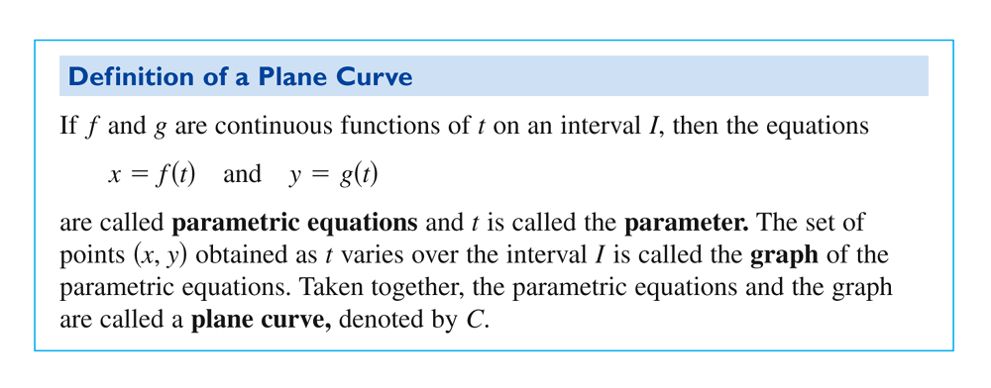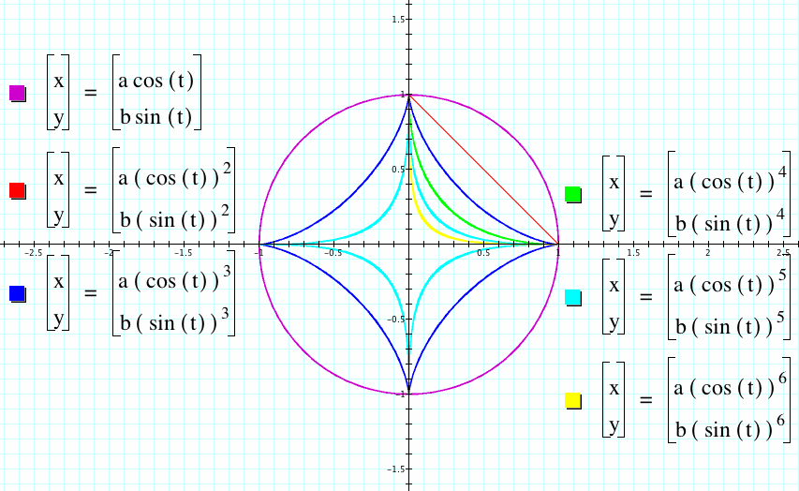 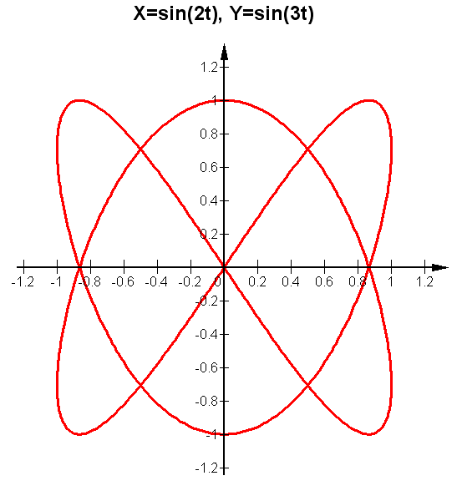

  

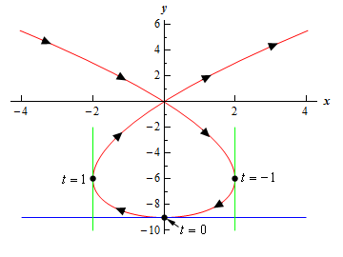 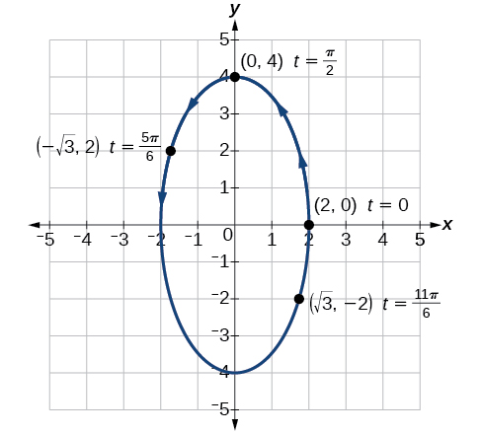 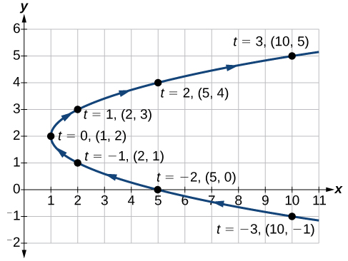

**Ex. 1:** Sketch the curve represented by the parametric equations and write the corresponding rectangular equation by eliminating the parameter. Complete the table.



|  |  |  |
| --- | --- | --- |
| t | x(t) | y(t) |
|  |  |  |
|  |  |  |
|  |  |  |
|  |  |  |
|  |  |  |
|  |  |  |
|  |  |  |
|  |  |  |
|  |  |  |
|  |  |  |

**More Ex. 1:**

**Ex. 2:** Sketch the curve represented by the parametric equations and write the corresponding rectangular equation by eliminating the parameter. Use your graphing utility to confirm your result. Complete the table.



|  |  |  |
| --- | --- | --- |
| t | x(t) | y(t) |
|  |  |  |
|  |  |  |
|  |  |  |
|  |  |  |
|  |  |  |
|  |  |  |
|  |  |  |
|  |  |  |
|  |  |  |
|  |  |  |

**Ex. 3:** Sketch the curve represented by the parametric equations and write the corresponding rectangular equation by eliminating the parameter. Use your graphing utility to confirm your result. Complete the table.



|  |  |  |
| --- | --- | --- |
| *θ* | x(*θ*) | y(*θ*) |
|  |  |  |
|  |  |  |
|  |  |  |
|  |  |  |
|  |  |  |

**Ex. 4:** Sketch the curve represented by the parametric equations and write the corresponding rectangular equation by eliminating the parameter. Use your graphing utility to confirm your result. Complete the table.



|  |  |  |
| --- | --- | --- |
| t | x(t) | y(t) |
|  |  |  |
|  |  |  |
|  |  |  |
|  |  |  |
|  |  |  |
|  |  |  |
|  |  |  |

Compare on your graphing utility:

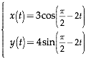

**Ex. 5:** Find a set of parametric equations for the line that passes through the points and  and write the corresponding rectangular equation by eliminating the parameter. Use your graphing utility to confirm your result.